Smart Locking System

Mark Rodriguez, Noor Pirzada, Idoko Abuh, Ali Al-Hajri

University of Central Florida School of Electrical and Computer Engineering Orlando, Florida 32826, USA

***Abstract –* The objective of this project is to design the most innovative smart lock system that combines multiple features in one package to provide a dependable, accurate, and convenient way to unlock and lock one’s home. The group selected this project as our senior design project because we felt we could improve the smart capabilities of a home locking system that are already available to consumers. The project also involves both computer and electrical engineering skillsets in order to successfully achieve and thus we felt that this project would allow us to represent our capabilities as future computer and electrical engineers.**

1. Introduction

Smart technology has revolutionized the way we perform our daily tasks by simplifying processes, increasing convenience, and improving reliability. Smart lock technology has been around since the last decade and has been slowly improving throughout the years. By combining technologies such as radio frequency identification (RFID), Bluetooth, liquid-crystal display (LCD) touchpads, finger-print sensors, and facial recognition cameras, companies have changed the way people access their homes and offices. The smart lock designed in this project takes all of these technologies and wraps them up in one convenient package. To control all of the components in our design, a microcontroller was utilized which consumes minimal amounts of power, provides a variety of communication protocols, has many I/O pins to allow for add-on features in future generations, and is robust to provide durability. The responsibility of the microcontroller is to read sensory data from each of the components, verify user access, and if valid, unlock the magnetic latch to grant the user access. In addition, the microcontroller stores user account information and has the ability to create new user accounts by utilizing the touch screen display to allow the user to input the required information. We also have a mobile application to allow users to create accounts via their mobile device as well as unlock the smart lock system by using the Bluetooth feature.

II. System Components

To offer the most convenience possible to our customers, many components were incorporated into the Smart Lock System. Each of the main components of the Smart Locking System will be reviewed in greater detail in this section.

1. *Microcontroller*

When selecting a microcontroller for

this project, we looked for a model that was affordable, provided great internal memory capacity to store user accounts, provided a large number of I/O pins, has plenty of online support, and most importantly, provides enough communication protocols for each module. After careful consideration, our group selected the ATMega 2560-AU microcontroller. It has a 16 MHz clock speed, 256 KB of memory, 86 I/O pins, and has 4 USART communication channels. at only $12 per unit, it is affordable and has a surplus of support provided by the Microchip website, GitHub, the ATMega 2560 manual, and Atmel Studio.

1. *Radio Frequency Identification*

The RFID sensor utilizes

electromagnetic fields to detect a signal from a programmed chip. The chip is often embedded in either a card or dongle and is to be held by the user who wishes to gain access. On the other hand, the RFID reader is usually mounted onto a device where the user is to swipe or wave the RFID chip to engage a connection. The chip contains tracking information which the reader detects and then uses it to grant the user access. The RFID reader in this project is the RC 522. This model is affordable, and more RFID cards can be purchased separately at a nominal price. This model is also great because it is compatible with our microcontroller.

*C. LCD Display*

The multicolored TFT flat panel

selected for our project works with both 3.3V. Compatibility with our microcontroller was assured by implementing logic converters to provide the appropriate voltages. The current consumption is roughly 300mA. This display utilizes 34 pins as seen in the pin configuration diagram in Figure 1.

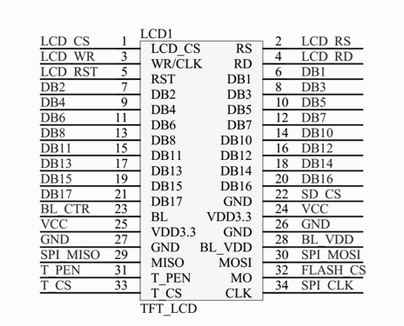

Fig. 1. Pin layout for TFT touch display

The display uses the ILI9431 chip to drive the display and is controlled using 11 pins. The LCD display allows user to create new user accounts and serves as a keypad for users to enter a code to unlock the door. Once the user enters a valid pin code, they are granted access and LCD displays a welcome message that is personalized for the person based on the code entered.

1. *Fingerprint sensor*

The optical fingerprint sensor works by shining a beam of light through the fingerprint and then captures the light that is reflected. Areas containing fingerprint ridges are brighter than areas containing fingerprint valleys. The image contrast is then inverted, making the ridges appear as dark lines. The system then takes various points in the print and compares it to the stored fingerprint data to see if the print read is a match. If it is, then the user is granted access. This technology is very useful because everyone has a unique fingerprint and thus is an excellent way of authenticating access to only specific users. Our project utilizes the GT511C3 sensor as it is affordable and allows for up to 20 prints to be stored which is sufficient for home use.

*E. Bluetooth Module*

The Bluetooth module is an option we

included in the Smart Lock System because it would allow users to unlock their door using their mobile device. The idea is that once the user’s phone is able to pair with the smart lock, the door automatically becomes unlocked, allowing the user to enter without having to reach for their phone. This method of authentication is very convenient and inexpensive while consumes very little power to run. Bluetooth 4.2 requires very little power to run and offers greater range for connection. This means that the user does not have to be within a few feet to pair but instead, the pairing will occur once the user is at their driveway. The Bluetooth module utilized for our project is the ESP 32 BLE which is compatible with our microprocessor and has plenty of user support available online.

1. *Facial Recognition Camera*

Initially, we planned on adding a human

vision component to our project if we had sufficient time to add it to our project. Having implemented the other features into our project, we decided to incorporate a facial recognition camera into our project. The camera, like the fingerprint sensor, takes an image of the person’s face and then takes various facial measurements of the person and compares it to stored values to see if the face is a match. If it is, the system grants the user authentication. The camera we selected for our project is the Omron B5T-007001-010. While on the higher end of the price spectrum, we decided on this model because it has its own integrated processor which is able to handle all of the image processing on its own. This was really important because had we had to design our own imaging processor; we would have not been able to achieve this feature on this type of project because it would have required a greater amount of time. This product has excellent online reviews and after testing, we determined that it works perfectly for our project.

III. System Concept

This section goes over the complete system by reviewing the flow chart to learn how all of the integrated components work together.

Fig. 2. Block diagram for Smart Lock System

The block diagram in Figure 2 describes the architecture of our smart lock and assigns the person responsible for working on the feature. The controller is the ATMega 2560-AU microprocessor described earlier and is the brains of our project. It handles all the processing and disengages the lock when authentication has been confirmed. In the diagram we have the 5 main components listed previously connected to the controller. In addition, we see the LED indicator light to signify when the lock is in use along with the magnetic locking mechanism. All of the components require power to function and thus, we see the 12v input power, voltage regulator, and relay switch to protect the components. These are responsible for supplying 3.3V and 5V power to all of the components. The way the system works is that all components are left in an active state and once a component reads user feedback then it receives the sensory data whether it be an image of the fingerprint, face, RFID, or touchpad input. Then, the microprocessor processes this information and checks the input data received against the database to see if a match is obtained. If the data is valid, the microprocessor then turns on the LED indicator light and sends a signal to power on the magnetic lock. Powering on the magnetic lock, retrieves the latch allowing for the door to be opened. The LCD display aside from being a touchpad with digits to allow users to enter a code to unlock the door also acts as a user interface to create new user accounts with set lock codes. When a user creates a new account, the data is stored in the microprocessors memory and is held in storage for future authentication.

1. *System Hardware Concept*

Our system hardware concept was derived from our project specifications, objectives, and electrical standards. Initially, we derived a list of objectives that we set to achieve in this project. These objectives were:

* Durable
* Provide the most features
* Cost affordable
* Easy to use

Having determined our objectives, we then set a list of specifications for our project. The specifications were for power, safety, and feature specifications. These specifications allowed us to have a plan to be able to accomplish each of the main components for our project by outlining the systems, software, and hardware we would be utilizing in order to be able to succeed in delivering our project objectives. Next, we set our marketing requirements and outlined which objectives were highest in priority in comparison to our requirements. Table 1 lists our engineering design requirements based on our objectives and design specifications.

Table 1. Engineering Design Requirements

IV. Hardware Detail

The hardware implementation of the Smart Lock involved integrating a multitude of sensor modules with the Atmega2560. The TFT LCD interfaced with the Atmega2560 through the Serial Peripheral Interface bus. The Fingerprint sensor, Facial Recognition Camera, and RFID Scanner each interfaced with the Atmega2560 by using a channel of the Universal Synchronous Asynchronous Receiver Transmitter. Another channel of the Universal Synchronous Asynchronous Receiver Transmitter was used as an output for a terminal so that debugging could be implemented while running the code for the Smart Lock. A 5-volt relay was used to connect the lock to power and was interfaced to the Atmega2560 using one of the GPIO pins connected to a Bipolar Junction Transistor circuit designed to provide the relay with a nominal current while the GPIO pin is HIGH. For audible feedback, a piezoelectric buzzer was implemented using one of the GPIO pins. This buzzer beeps every time the LCD screen is engaged, giving the user audible feedback that their interaction has been registered by the software, improving user friendliness. A diagram of the hardware connections and communication protocol is provided below in figure

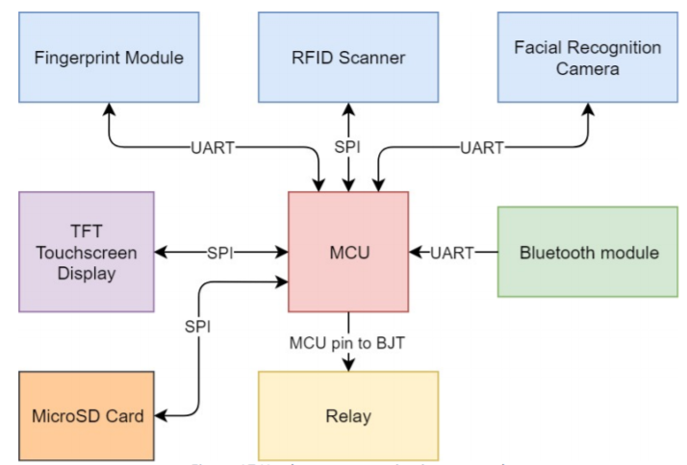

Fig 3. Hardware Communications Protocols

V. Power Detail

Through power calculations, we estimated that our project would us a maximum of 1.2 A so we set our power requirements for 12V 3A. This is because the magnetic lock we chose operates at 12 volts, and we wanted about 3 times our maximum current in order to avoid a loading effect on our power supply.

To deliver power to our smart lock project, we utilized a 12-volt 3A rectifier as our input voltage source. To filter our input signal we placed two capacitors in parallel with our input source and then utilized a synchronous buck converter to step down the voltage to 5 volts. This is necessary because all of our electrical components utilize either 5 volts or 3.3 volts to operate. Using this type of circuit allowed us to meet our power specifications such that we have sufficient power to run all of our components while utilizing a buck converter which meets safety standards for being able to handle an input power source of 12 volts without producing the danger of shock or fire hazard. We tested this circuit by powering on all of our electrical components and then verifying that the heat generated from the buck converter would not exceed the specifications for this model. We found that after many hours of remaining powered, we did not find any issues with this circuit design. Figure 3 demonstrates the circuit for our power delivery system.

Fig. 3. Power Circuit for Smart Lock System

VI. Software Detail

The embedded software was implemented using Atmel Studio and the Atmega2560 was programmed via an Atmel ICE hardware debugger module. Atmel Studio was chosen because of the seamless compatibility that it provides when programming AVR microchips. In addition, we wanted to include a mobile application for our project. To design a simple application that would be able to lock and unlock the magnetic lock, we decided on using React Native. React Native uses the JavaScript framework and Java library which is compatible in both Android and IOS. As a result, the mobile application can be installed on the google play store and apple store making it compatible with virtually all devices. Figure 4 demonstrates the layout of the application.

Fig. 4. Smart Lock System Mobile Application

To operate the mobile application, open the application on the phone and connect the Bluetooth to the smart lock. Then, you can unlock and lock the door by pressing the designated button on the application. When locking the door, a five second delay will occur allowing for someone to close the door if necessary, before the lock occurs. Once this time has passed, the lock will be initiated. Because our mobile application only utilizes bluetooth, we did not have to create any databases as a wifi module was not incorporated in this project.

1. *Embedded Hardware*

The Atmel ICE was chosen also for its seamless compatibility and ease of use. The ICSP connector allowed for fast and simple programming of the chip as well as provided a level of safety due to the connector orientation being labeled, avoiding misconnections.

1. *Embedded Software*

The embedded software boasts an efficient design that allows the microprocessor to idle within infinite loops. The code also allows for a total factory reset which is performed if the clear data pin is read as high during the startup. This was helpful during the testing and debugging phase due the ability to reset all the databases. After initializing all of the modules, the software is designed to wait for a user input using a system of interrupts to redirect the processor when an input is received. In Enroll Mode, User data is first enrolled into the system using the LCD touchscreen. Then fingerprint, RFID tag, and facial recognition data is then collected from the user via the different sensors. Afterward, the Run Program mode allows users to enter a password, scan an RFID tag, scan a fingerprint, or scan a face to attempt to gain access. The system receives the input and parses the database to verify if the input data matches the data that is in the database. If the user data is recognized, the software will allow access to the user and display “Access Granted” as well as the user’s name and clearance level.

VII. Board Design

When designing our printed circuit board PCB, we first looked at standards for PCBs. The standard that we used for our board is IPC-2221. This standard is for general electronic products including computer and computer peripherals. Our product falls under this specific class rating because it is a dedicated service electronic. Our product focuses on functionality, durability, and high reliability. To be qualified for this standard, our PCB must be susceptible to the elements of the environment, meaning that it should not lose reliability in the event of rain or high winds. We ensure this by creating a sturdy enclosure that will protect the PCB from the elements and ensure that when the environment becomes wet or windy, the internal PCB will not be affected. To design our PCB we settled on using Autodesk Eagle because we were most familiar with this product given that we had previously used this development tool in our junior design course. Eagle is a convenient tool because it allows you to create a circuit schematic based on the parts you will be using and then will allow you to create a bill of materials based on all the parts used. Also, Eagle allows you to create routes to connect all of your components to create board files which could be sent out to manufacturers of printed circuit boards so that they could print our board for us. Figure 5 shows an image of our final circuit for the Smart Lock System.

Fig. 5. Smart Lock System Circuit Board

From figure 5, we see that the placement of all of our components had to be meticulously thought out. As an example, through trial and error, we discovered that the Bluetooth module needed to be installed near the edge of the board because the electromagnetic frequency of the other components was affecting its performance. Also, another key feature of our circuit is the use of logic converters. Initially we wanted to add the circuit of the logic converters into our board but realized that this would be a difficult task because of the small size of the components, we decided to add a surface mount logic converter circuit to our board and added throughput holes in order to solder on the logic converters. We added three logic converters to our circuit, one for each of the main features in our smart lock. Logic converters are necessary in order to convert the small signals received from the components into readable signals that the microcontroller can process.

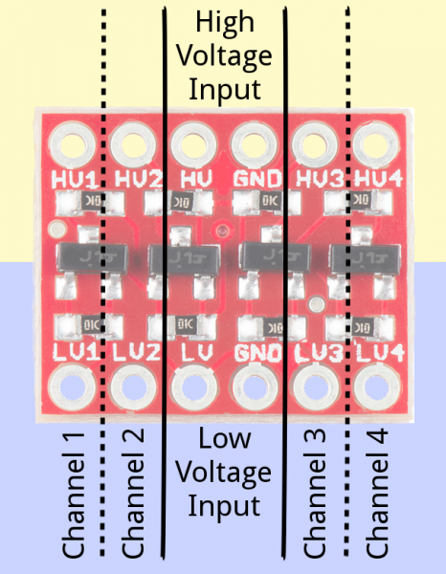

Fig. 6. Logic Converter

Figure 6 shows what the logic converter circuit looks like. From the schematic the pins labeled as HV, LV provide high and low voltage references. These logic converters take in a 3.3-volt signal in the LV pin and convert it to a 5-volt signal at its respective HV pin located directly above the LV pin. The purpose for this is that our microcontroller can only interpret 5-volt signals and thus component allows us to provide the microcontroller with a signal that it can interpret.

IX. Conclusion

Having completed this project in two semesters has been a rewarding experience for our group. We have learned how to work through adversities by relying on each other to complete the tasks we set for ourselves at the beginning of the project. This experience thought us how to work as a team and work through our differences to accomplish a greater goal. Part of success was scheduling frequent meetings in which we made sure we were all completing our tasks by the deadline and avoiding procrastination so that we had time to verify our work prior to submitting it to our faculty. Another factor that helped us reach our goal, was the amount of time we dedicated to testing our project. We realized that if we were able to start printing our circuit board early on in the project, it would allow us to have more time to test our circuit and apply necessary changes to attain a working model. In the end, we printed three different circuit boards until we finally worked out all of our issues. We also tested our product repeatedly in order to ensure that it would be able to function properly after many attempts. In doing so, we identified new issues that we would have missed had we not spent the time to quality control our product. Finally, the last factor that helped us succeed in our project was by identifying each of our strengths and then applying ourselves to complete tasks based on our skillsets. By assigning the person with the strongest experience in a particular area, we were able to save time and ensure that the end product would work as best possible. In addition, we made it possible for each of us to assist in all parts of the project so that we could use this project as an opportunity to continue to learn and develop skills for ourselves.

The Engineers

Idoko Abuh is a graduating Electrical Engineer student who will be pursuing a career as an Automotive Engineer at JM Family

Noor Pirzada is a graduating Computer Engineer student who plans to work in the

field of Software Engineering. She is open to relocating in pursue of obtaining her dream job

Mark Rodriguez is a graduating Electrical Engineer student. Mark hopes to continue his education to obtain a master’s degree in engineering management

while working as an Electrical Design Engineer.

Ali Al-Hajri is an Electrical Engineer Candidate, honors class of 2019, Ali is an aspiring engineer looking forward to continuing a master’s degree in Electrical Engineering Power and Renewable energy track.

Acknowledgements

The members of the smart lock system would like to thank Dr Richie Samuels for his willingness to help students meet their project deadlines. His encouragement and constructive criticism helped us improve our design so that our project outcome was better than what we had initially hoped for.

References

[1] Microchip. (2019) Atmega2560 Datasheet. Retrieved 16 November 2019. World Wide Web: http://ww1.microchip.com/downloads/en/DeviceDoc/Atmel-2549-8-bit-AVR-Microcontroller-ATmega640-1280-1281-2560-2561_datasheet.pdf

[2] Sparkfun. (2019) Bi-Directional Logic Level Converter Hookup Guide. Retrieved 19 November 2019. World Wide Web: https://learn.sparkfun.com/tutorials/bi-directional-logic-level-converter-hookup-guide/all